Derivation of typical diatom assemblages

14.09.20

Jonathan Jupke

How were the diatom data sets harmonized?

International diatom occurrence data sets require extensive harmonization because of the taxonomic resolution differing between data sets, different working groups using different nomenclatures, identification errors, and ongoing changes to the accepted nomenclature (Kahlert et al., 2020). Harmonization can reduce overall taxonomic resolution but can improve the detection of large-scale spatio-temporal patterns (Lee et al., 2019). We compared all our data sets against a series of databases that contain accepted names, synonyms with links to the respective accepted names and suggestions for grouping contentious taxa in larger complexes. If a taxon name was found in one of the databases the name was accepted, changed into the accepted name in case it was a synonym, or grouped into the respective complex. Once a taxon was found in a database, it would not be included in queries of subsequent databases. However, if the accepted name differed from the original one, the accepted name would be queried through all previous databases again. The results were also controlled visually for consistency. The following databases were used in the same order:

1. Table S2 from (Kahlert et al., 2020)
2. The taxon list associated with the OMNIDA software (Lecointe, 2017)
3. (Mauch et al., 2017)
4. (Rimet et al., 2019)
5. algaebase.org
6. global biodiversity information platform (gbif.org)

What is the optimal taxonomical level?

To identify the optimal level taxonomical level, we employed the same approach as for the invertebrates. We used a cutoff of 75% instead of 85%, because *Gomphonema*, which is the fourth most common genus in our data set, had 81.43% observations at the species level. In the diatom data, the taxonomical resolution was higher than in the macroinvertebrate data. The lowest resolution in the final data set is the genus level.

Can we represent the stream types with those samples?

Whether a stream type is sampled extensively enough in our data to derive meaningful Typical assemblage (TA) was determined visually. Maps with all streams that belong to one stream type and all associated sampling sites are uploaded to the [Get Real Drive](https://drive.google.com/drive/folders/1CDXy6Zkwhi_7esAAFYU9rYCBTqtaPr3Q). The representativeness was graded in a three-tier system: good, medium, bad. Good representativeness indicates, that we have ample sampling locations, which are distributed evenly across the instances of a stream type that fall within the countries considered in GetReal. Bad representativeness indicates the opposite, i.e. few sites, and those are clustered spatially. A medium rating implies that we either have many sampling sites, but these only extend over parts of the countries or few sites that extend over most of the countries. Further analyses were conducted for all stream types with medium representation, as none were graded as good. More information on the river types is available in the [accompanying publication](https://www.sciencedirect.com/science/article/pii/S0048969719340203). In general, we have fewer sampling sites for the diatoms than for the macroinvertebrates which entails that the representation of stream types is generally worse. Additionally, sites from France often outnumber all others due to the large amount of data we have from France.

Good [n = 0]:

Medium [n = 14]: 1, 2, 3, 4, 5, 6, 8, 9, 12, 14, 16, 17, 18, 19

Bad [n = 6]: 7, 10, 11, 13, 15, 20

What is a typical assemblage?

As before TAs were derived based on a rule that considered

1. The probability of site *x* belonging to stream type *z* given species *y* is present (a measure of specificity, henceforth **A**)
2. The probability of species *y* being present given that site *x* belongs to stream type *z* (a measure of commonness, henceforth **B**)
3. The Species Indicator Value

The Species Indicator Value (Cáceres & Legendre, 2009; Dufrêne & Legendre, 1997) is the weighted product of **A** and **B** (Eqn. 1)

Equation 1

where Np is the number of sites that belong to stream type p and np the number of occurrences of the focal species in sites of type p. K is the number of stream types. **A** is weighted by the total number of occurrences to account for unequal sample sizes. The statistical significance of the Indicator Value can be assessed with permutation-based pseudo-*p*-values, which we did with 999 permutations.

 Here, we are not interested in indicator species for each community, but TAs. Hence, simply continuing with those species that have a pseudo-*p-value* below some significance level would not serve our purpose. A species that occurs at each site, across all stream types, highlights the difference: while it would not be indicative of any stream type (low specificity) it should be part of each TA. Hence, we need additional criteria to derive the TAs which can be based on **A**, **B**, and the pseudo*-p-value* of the indicator value. We used the following rules:

Species where considered typical if **B** > 0.4 or **B** > 0.3 and p < 0.05 or **A** > 0.7.

Genera where considered typical if **B** > 0.8 or **B** > 0.6 and p < 0.05 or **A** > 0.95.

Note that there was no systematic optimization used to define these thresholds. Such procedures would require optimization criteria, but we are not aware of a criterion that would work in this context. We acknowledged that typical assemblages could be (i) very similar in composition or (ii) harbor strongly differing numbers of taxa. Thus, parametrizing the rules in a way that would (i) maximize dissimilarity between assemblages or (ii) maximize the mean assemblage richness would not lead to what we consider a typical assemblage. It would be possible to try a cross-validation-type approach where each taxon is scored based on the number of random-site-subsets it is included in, but such an approach would also entail making essentially arbitrary numerical assumptions. We think the use of subjectively defined thresholds is justified, as long as they are clearly and openly communicated, to be what we define as “typical assemblages”.

However, we conducted a sensitivity analysis to see how much varying the parameters of the rules would alter the results. We altered the threshold values of A and B. The rules above contain two distinct threshold values for B: B1 which does not consider the pseudo-*p­*-value (B > 0.4 for species) and B2 which does take the pseudo-*p­*­-value into account (**B** > 0.3 and p < 0.05). In the following simulations, the B2 was always taken to be 25% below B1. Henceforth, when referring to the threshold for B, we refer to B1. We varied the threshold for B in ten steps between 0.10 and 0.75 and that for A in ten steps between 0.5 and 1.0. Species richness and uniqueness scores of each TA were computed for all 100 combinations of these parameters. Please note that results are only shown and discussed for the non-redundant TAs (see the next section). Species richness decreased with increasing A and B threshold (Figure 1 and Figure 2), while the uniqueness scores increased with B thresholds but decreased with A thresholds (Figure 3 and Figure 4). The rate of change in species richness along gradients in A and B threshold differed markedly between TAs but seemed to be correlated with overall species richness, i.e. more species-rich TA lost species more quickly than less species-rich ones. The TAs of RT03 and RT16 serve as examples at both extremes of our data set. Uniqueness scores decreased noticeably with very high A thresholds (> 0.9), indicating that taxa that are specific to certain river types are an important driver of TA differentiation.

Redundancy in typical assemblages

We assessed to which degree the different TAs overlap (Table 1). The degree of overlap is the percentage of taxa in a TA that is also present in the most similar (largest overlap) TA.

Table 1: Redundancy between TAs

|  |  |  |
| --- | --- | --- |
| River type | Most similar river type(s) | Degree of overlap |
| RT01: Very Large Rivers | RT02 | 62.9% |
| RT02: Lowland, siliceous, medium-large | RT01 | 46.8% |
| RT03: Lowland, siliceous, very small-small | RT02 | 48.7% |
| RT04: Lowland, calcareous or mixed, medium-large | RT02 | 74.1% |
| RT05: Lowland, calcareous or mixed, very small-small | RT02 | 62.5% |
| RT06: Lowland, organic and siliceous, very small-large | RT12 | 38.3% |
| RT08: Mid-altitude, siliceous, medium-large | RT02 | 71.4% |
| RT09: Mid-altitude, siliceous, very small-small | RT05 + RT08 | 56% |
| RT12: Mid-altitude, organic and siliceous, very small-large | RT06 | 40.9% |
| RT16: Glacial rivers (all Europe) | RT 18 | 56.5% |
| RT17: Mediterranean, lowland, medium-Large, perennial | RT01 | 63% |
| RT18: Mediterranean, mid-altitude, medium-large | RT01 | 71.4% |
| RT19: Mediterranean, very small-small, perennial | RT17 | 68.4% |

Again, choosing a threshold above which we consider two assemblages to be redundant is somewhat arbitrary. We proceeded with 75% but are open to other suggestions. This threshold leads to no redundant assemblages.

What do the typical assemblages look like?

In all TAs, species is the prevalent taxonomic level (see Figure 5). Some assemblages consist entirely of species (i.e. RT04, 06, 09, 16, 17, and 19). The mean number of species per TA is 30 and the mean number of genera 0.5. RT03 has the most taxa rich TA with 49 taxa and RT19 the most taxa poor with 18.

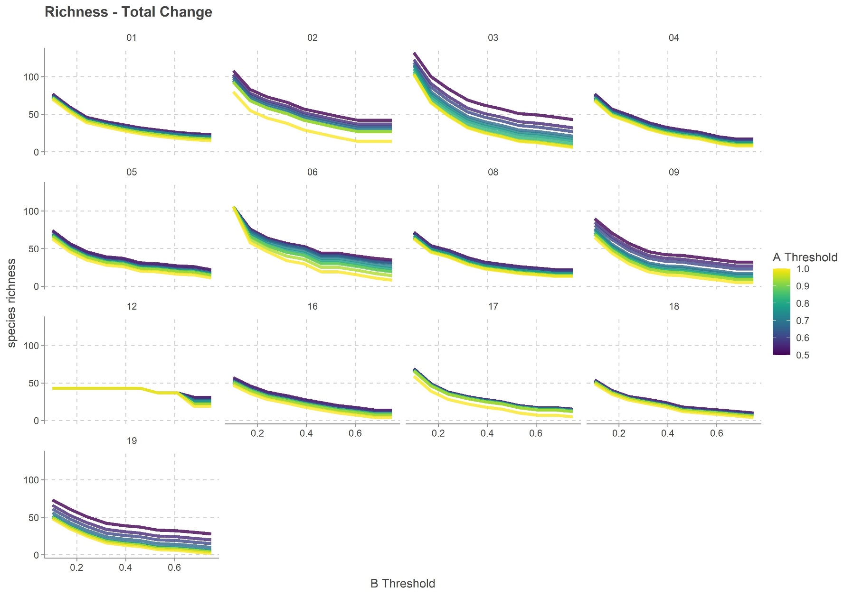

Figure 1: Changes in species richness along a changing B threshold. Line color indicates the employed A threshold.

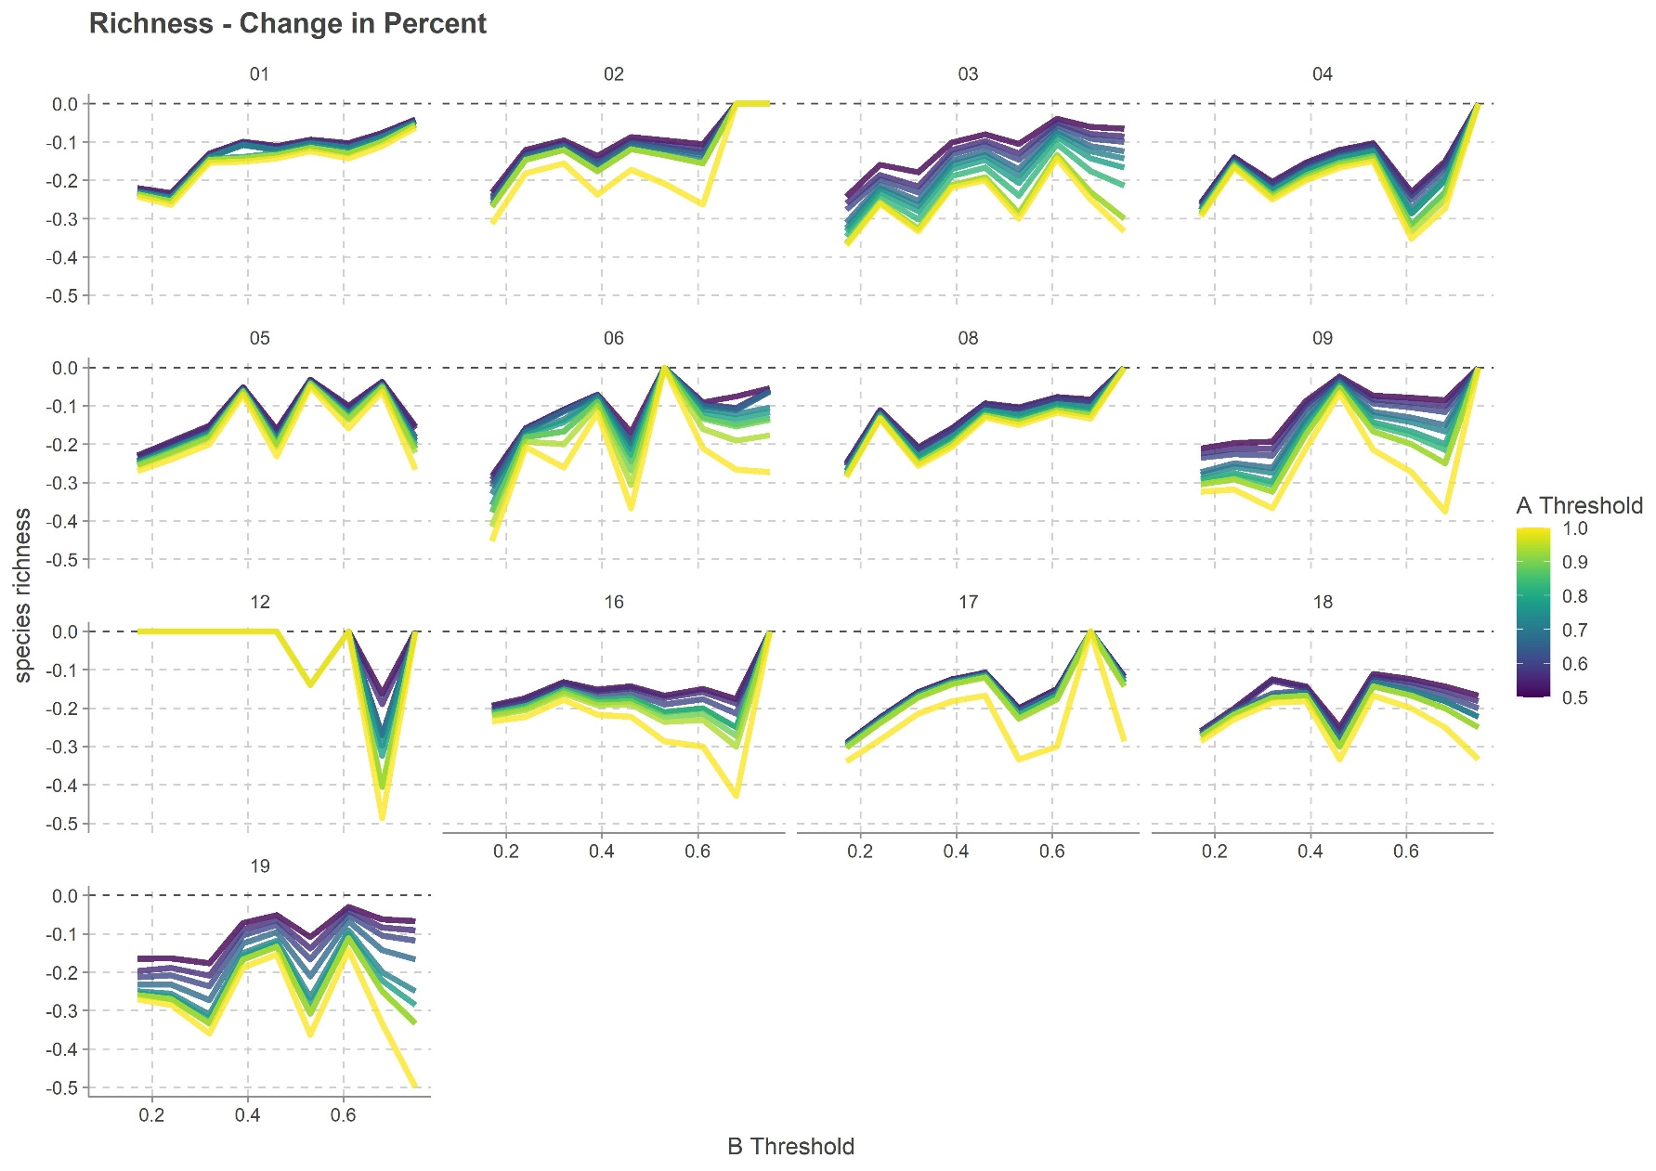

Figure 2: Changes in species richness along a changing B threshold expressed in percent. Line color indicates the employed A threshold. The dashed line marks the change rate of 0%.

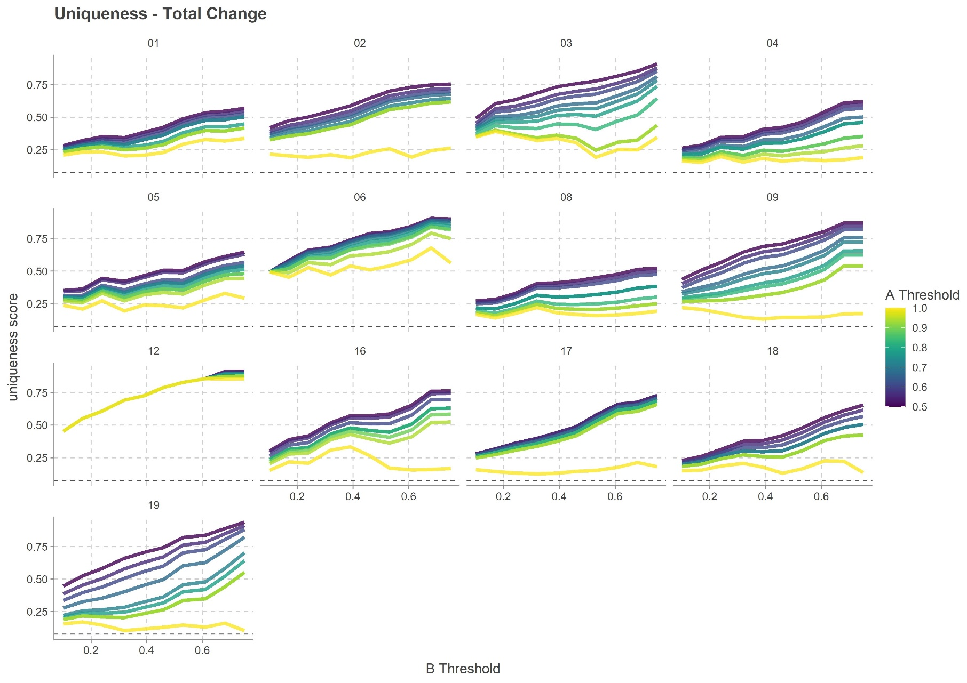

Figure 3: Changes in uniqueness scores along a changing B threshold. Line color indicates the employed A threshold. The dashed line shows the minimum possible uniqueness score of 1/11 = 0.91.

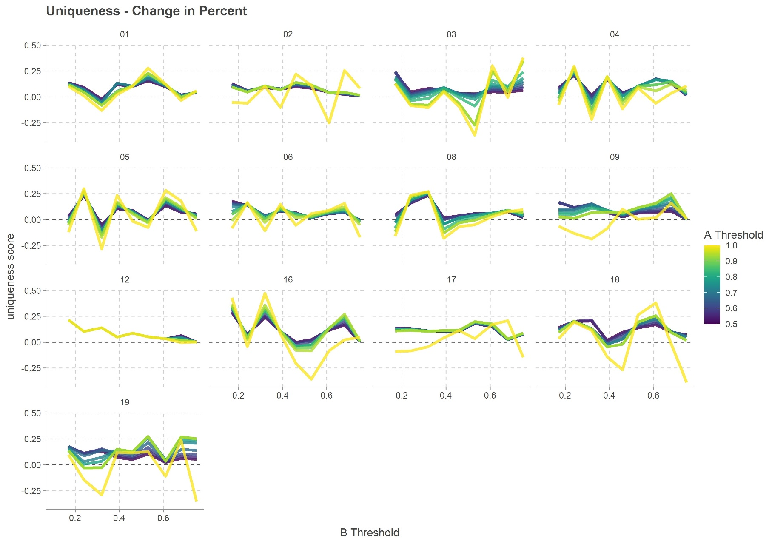

Figure 4: Changes in uniqueness scores along a changing B threshold expressed in percent. Line color indicates the employed A threshold. The dashed line marks the change rate of 0%.

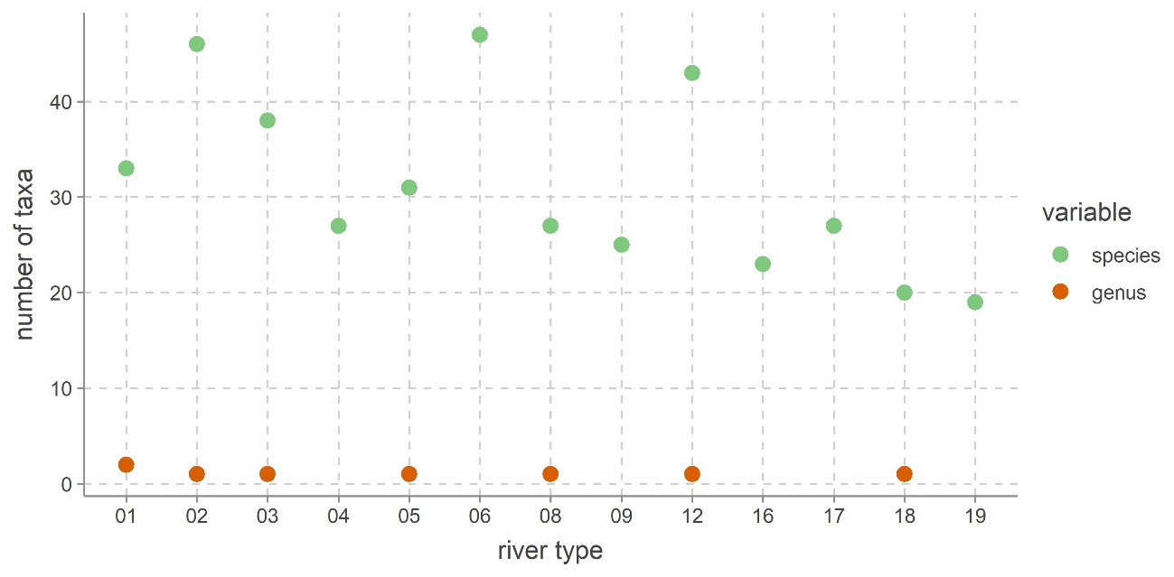

Figure 5: Numbers of taxa on each taxonomical level for all typical assemblages. Dots were removed if the number of taxa was zero.

We can express the uniqueness of a TA with the following score: Each taxon receives a taxon uniqueness score which is one divided by the number of TAs it occurs in. For each river type, we sum the taxon scores of all taxa up and divide it by the number of taxa in the river type’s TA. If all taxa in the TA are unique to that TA the score is one. If all species occur in one other TA the score is 0.5. The minimal score depends on the number of TAs, as it is 1 divided by that number and it signals that all species in that TA occur in all other TAs. These scores are shown in Figure 6. The dashed horizontal line indicates the minimum score.

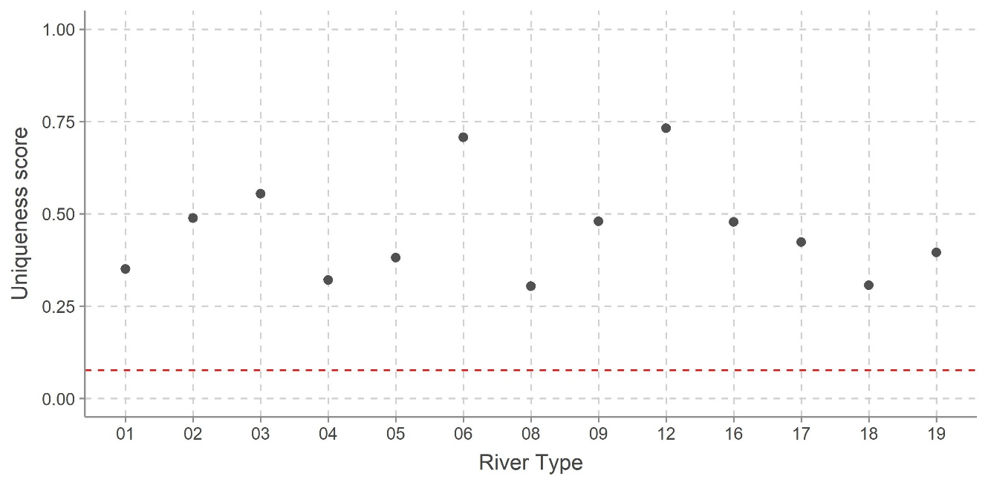

Figure 6: Uniqueness scores for all typical assemblages. The red dashed line indicates the minimum possible score of 0.08.

To visualize how similar or dissimilar the TAs are, we used a Principal Coordinates Analysis (PCoA, Figure 8). The latter is based on a Jaccard distance matrix.

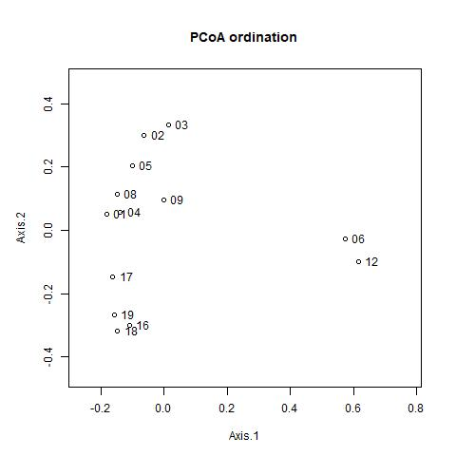

Figure 8: PCoA and NMDS of typical assemblages

The river types RT16 to 19 form one group. RT17 to 19 are Mediterranean streams and RT16 are glacial streams that also fall mainly within the region (the Pyrenees, the Western Alps, and the Central Alps. We do not have sampling sites in the later). RT17 (Mediterranean, lowland, medium-Large, perennial) is further removed from the core of the cluster. The second cluster consists of river types RT1 to 5 as well as RT8 and 9. The river types RT01, 4, 8 are one subcluster as are RT02 and 03. RT 05 connects the first to the second subcluster and RT09 is more similar to the first but noticeably removed from it. RT02 3 are both lowland, siliceous rivers. RT02 represents larger and RT03 smaller rivers.

The two TAs RT06 and RT12 are further removed from the formerly described clusters. Both represent rivers that are highly influenced by organic matter, which is known to impact diatom communities (Hering et al., 2006).

Typical assemblages

Below we list the different taxa that belong to the TAs.

RT01 Very large rivers

Achnanthidium eutrophilum, Achnanthidium minutissimum, Amphora pediculus inariensis Complex, Anomoeoneis sphaerophora, Cocconeis euglypta, Cocconeis pediculus, Cyclotella wuethrichiana, Cymbella excisa, Diatoma vulgaris, Encyonema silesicacum minutum lange bertalotii, Eolimna comperei, Eolimna minima seminulum atomoides, Gomphonema olivaceum olivaceoides, Gomphonema parvulum Complex, Gomphonema pumilum complex, Halamphora montana, Luticola ventriconfusa, Mayamaea permitis, Navicula capitatoradiata, Navicula cryptotenella cryptotenelloides, Navicula gregaria, Navicula margalithii tripunctata, Navicula menisculus antonii, Navicula reichardtiana caterva, Navicula rotunda, Nitzschia dissipata recta Complex, Nitzschia fonticola Complex, Nitzschia inconspicua Complex, Nitzschia palea paleacea, Nitzschia sociabilis, Reimeria sinuata, Reimeria uniseriata, Sellaphora submuralis Complex, Gomphonema, Rhoicosphenia

RT02 - Lowland, siliceous, medium-large

Achnanthidium minutissimum, Amphora pediculus inariensis Complex, Brachysira styriaca, Cocconeis euglypta, Cocconeis pediculus, Cocconeis placentula, Conticribra guillardii, Delphineis surirella, Diatoma vulgaris, Discostella complex, Encyonema silesicacum minutum lange bertalotii, Entomoneis paludosa, Eolimna minima seminulum atomoides, Eunotia subarcuatoides, Eunotia subtilissima, Fallacia subhamulata helensis, Gomphonema parvulum Complex, Gomphonema saprophilum, Halamphora montana, Mayamaea permitis, Melosira varians Complex, Navicula capitatoradiata, Navicula cryptotenella cryptotenelloides, Navicula gregaria, Navicula lanceolata complex, Navicula margalithii tripunctata, Navicula menisculus antonii, Navicula reichardtiana caterva, Neidium dubium Complex, Nitzschia amphibia Complex, Nitzschia angustiforaminata, Nitzschia dissipata recta Complex, Nitzschia fonticola Complex, Nitzschia labella, Nitzschia palea paleacea, Nitzschia pura linearis Complex, Nitzschia sociabilis, Nitzschia subcapitellata, Pinnularia divergens complex, Plagiogramma laeve, Planothidium lanceolatum, Rhaphoneis amphiceros, Sellaphora submuralis Complex, Skeletonema subsalsum, Thalassiosira bramaputrae, Thalassiosira proschkinae, Rhoicosphenia

RT03 - Lowland siliceous, very small-small

Achnanthidium minutissimum, Amphora pediculus inariensis Complex, Campylosira cymbelliformis, Cocconeis placentula, Cyclostephanos Complex, Cyclostephanos tholiformis, Cyclotella hakanssoniae, Cyclotella meneghiniana, Dimeregramma minor, Discostella complex, Encyonema triangulum, Eolimna minima seminulum atomoides, Fallacia crassicostata, Gomphonema parvulum Complex, Gomphonema pumilum complex, Halamphora coffeaeformis, Halamphora montana, Melosira varians Complex, Navicula cryptotenella cryptotenelloides, Navicula gottlandica, Navicula gregaria, Navicula lanceolata complex, Navicula margalithii tripunctata, Nitzschia amphibia Complex, Nitzschia dissipata recta Complex, Nitzschia inconspicua Complex, Nitzschia lacuum alpina bryophila , Nitzschia palea paleacea, Nitzschia perspicua, Nitzschia pura linearis Complex, Nitzschia sociabilis, Planothidium lanceolatum, Platessa bahlsii, Rossithidium linearis, Staurosira punctiformis, Stephanodiscus hantzschii, Surirella brebissonii, Thalassiosira decipiens, Rhoicosphenia

RT04 - Lowland calcareous, medium-large

Achnanthidium minutissimum, Amphora ocellata, Amphora pediculus inariensis Complex, Caloneis bacillum Complex, Cocconeis euglypta, Cocconeis pediculus, Cocconeis placentula, Cyclotella striata, Encyonema silesicacum minutum lange bertalotii, Eolimna minima seminulum atomoides, Gomphonema hebridense, Gomphonema olivaceum olivaceoides, Gomphonema parvulum Complex, Halamphora montana, Navicula capitatoradiata, Navicula cryptotenella cryptotenelloides, Navicula margalithii tripunctata, Navicula menisculus antonii, Navicula reichardtiana caterva, Nitzschia amphibia Complex, Nitzschia dissipata recta Complex, Nitzschia fonticola Complex, Nitzschia palea paleacea, Nitzschia sociabilis, Planothidium lanceolatum, Stephanodiscus niagarae complex, Thalassiosira gessneri

RT05 - Lowland calcareous, very small-small

Achnanthes coarctata, Achnanthidium lauenburgianum, Achnanthidium minutissimum, Amphora pediculus inariensis Complex, Caloneis bacillum Complex, Cocconeis euglypta, Cocconeis placentula, Encyonema silesicacum minutum lange bertalotii, Eolimna minima seminulum atomoides, Fallacia subhamulata helensis, Gomphonema dichotomum, Gomphonema parvulum Complex, Gomphonema pumilum complex, Halamphora montana, Hantzschia abundans, Mayamaea Complex, Melosira varians Complex, Navicula cryptocephala, Navicula cryptotenella cryptotenelloides, Navicula gregaria, Navicula margalithii tripunctata, Navicula menisculus antonii, Navicula reichardtiana caterva, Neidiomorpha binodeformis, Neidium iridis Complex, Nitzschia dissipata recta Complex, Nitzschia palea paleacea, Nitzschia sociabilis, Planothidium lanceolatum, Reimeria sinuata, Tabellaria fenestrata Complex, Rhoicosphenia

RT06 - Lowland, organic and siliceous, very small-large

Achnanthes rupestoides kryophila broenlundense, Achnanthidium minutissimum, Aneumastus stroesei, Cavinula scutelloides pseudoscutiformis, Diatoma anceps, Encyonema silesicacum minutum lange bertalotii, Eunotia exigua elegans Complex, Eunotia arcus mucophila bilunaris Complex, Eunotia Complex, Eunotia implicata Complex, Eunotia incisa Complex, Eunotia parallela Complex, Eunotia pectinalis Complex, Eunotia septentrionalis, Fragilaria capucina complex, Frustulia rhomboides Complex, Gomphonema angustatum Complex, Gomphonema parvulum Complex, Humidophila schmassmannii, Karayevia amoena nitidiformis, Meridion circulare Complex, Navicula cryptocephala, Navicula rhynchocephala, Nitzschia dissipata recta Complex, Nitzschia flexa, Nitzschia palea paleacea, Nitzschia perminuta Complex, Nitzschia pura linearis Complex, Odontidium mesodon, Pinnularia appenticulata perirrorata silvatica, Pinnularia interrupta Complex, Pinnularia mesolepta Complex, Pinnularia sinistra, Pinnularia subcapitata Complex, Pinnularia viridis complex, Planothidium lanceolatum, Platessa oblongella, Psammothidium curtissimum, Psammothidium helveticum chlidanos daonense, Psammothidium subatomoides, Psammothidium ventrale Complex, Rossithidium petersennii, Rossithidium pusillum anastasiae, Stauroneis complex small, Stauroneis phoenicenteron Complex, Tabellaria flocculosa Complex, Ulnaria ulna complex

RT08 - Mid-altitude, siliceous, medium-large

Achnanthidium minutissimum, Amphora pediculus inariensis Complex, Cocconeis euglypta, Cocconeis placentula, Encyonema silesicacum minutum lange bertalotii, Eolimna minima seminulum atomoides, Gomphoneis eriense, Gomphonema bavaricum, Gomphonema parvulum Complex, Gomphonema pumilum complex, Humidophila perpusilla, Mayamaea alcimonica, Mayamaea permitis, Melosira varians Complex, Navicula cryptotenella cryptotenelloides, Navicula gregaria, Navicula lanceolata complex, Navicula margalithii tripunctata, Navicula reichardtiana caterva, Nitzschia costei, Nitzschia dissipata recta Complex, Nitzschia fonticola Complex, Nitzschia inconspicua Complex, Nitzschia palea paleacea, Planothidium lanceolatum, Reimeria sinuata, Sellaphora submuralis Complex, Rhoicosphenia

RT09 - Mid-altitude siliceous, very small-small

Achnanthidium minutissimum, Amphora micra, Amphora pediculus inariensis Complex, Chamaepinnularia submuscicola, Cocconeis euglypta, Cocconeis placentula, Encyonema silesicacum minutum lange bertalotii, Eolimna minima seminulum atomoides, Eolimna neocaledonica, Fragilaria heidenii, Gomphonema parvulum Complex, Navicula cryptocephala, Navicula cryptotenella cryptotenelloides, Navicula gregaria, Navicula lanceolata complex, Navicula venezuelensis, Naviculadicta cosmopolitana, Nitzschia dissipata recta Complex, Nitzschia frequens, Nitzschia inducta, Nitzschia palea paleacea, Nitzschia valdecostata, Planothidium lanceolatum, Reimeria sinuata, Tabellaria quadriseptata Complex

RT12 – Mid-altitude, organic and siliceous

Achnanthidium linearioide, Achnanthidium minutissimum, Brachysira neoexilis, Brachysira zellensis, Caloneis tenuis Complex, Cavinula scutelloides pseudoscutiformis, Chamaepinnularia begeri mediocris, Diatoma mesodon, Discostella complex, Encyonema gaeumannii perpusillum, Encyonema gracile luna, Encyonema silesicacum minutum lange bertalotii, Encyonopsis descripta falaisensis microcephala, Eucocconeis laevis alpestris, Eunotia exigua elegans Complex, Eunotia arcus mucophila bilunaris Complex, Eunotia implicata Complex, Eunotia incisa Complex, Eunotia naegelii, Eunotia pectinalis Complex, Eunotia praerupta Complex, Fragilaria arcus, Fragilaria capucina complex, Fragilaria construens pseudoconstruens, Fragilaria tenera complex, Frustulia rhomboides Complex, Gomphonema acuminatum Complex, Gomphonema parvulum Complex, Lindavia rossii complex, Navicula angusta, Navicula notha leptostriata, Neidium affine Complex, Nitzschia bavarica Complex, Nitzschia perminuta Complex, Pinnularia subcapitata Complex, Planothidium lanceolatum, Psammothidium marginulatum scoticum lacus vulcani levenderi, Psammothidium rossii altaica, Psammothidium ventrale Complex, Rossithidium nodosum, Rossithidium pusillum anastasiae, Tabellaria flocculosa Complex, Ulnaria ulna complex, Stenopterobia

RT16 – Glacial Rivers

Achnanthidium atomoides, Achnanthidium minutissimum, Achnanthidium subatomus, Amphora pediculus inariensis Complex, Cocconeis euglypta, Cocconeis placentula, Cocconeis pseudolineata, Cymbella tridentina, Diadesmis gallica, Diatoma moniliformis tenuis, Distrionella incognita, Encyonema silesicacum minutum lange bertalotii, Fragilaria incognita, Fragilaria virescens complex, Gomphonema olivaceum olivaceoides, Gomphonema parvulum Complex, Gomphonema pumilum complex, Navicula cryptotenella cryptotenelloides, Navicula margalithii tripunctata, Nitzschia dissipata recta Complex, Nitzschia fonticola Complex, Odontidium hyemale, Reimeria sinuata

RT17 - Mediterranean, lowland, medium-Large, perennial

Achnanthidium minutissimum, Amphora pediculus inariensis Complex, Aneumastus tusculus, Brachysira garrensis, Cocconeis euglypta, Cocconeis pediculus, Cocconeis placentula, Cymbella excisa, Cymbella kappii, Diatoma vulgaris, Encyonema silesicacum minutum lange bertalotii, Encyonema simile, Eolimna minima seminulum atomoides, Fallacia muraloides, Gomphonema parvulum Complex, Gomphonema pumilum complex, Luticola kotschyi, Navicula cryptotenella cryptotenelloides, Navicula margalithii tripunctata, Navicula reichardtiana caterva, Nitzschia dissipata recta Complex, Nitzschia fonticola Complex, Nitzschia inconspicua Complex, Nitzschia palea paleacea, Planothidium holstii, Planothidium reichardtii, Pseudostaurosira neoelliptica

RT18 - Mediterranean, mid altitude, medium-large, perennial

Achnanthidium minutissimum, Amphora pediculus inariensis Complex, Cocconeis pediculus, Cocconeis placentula, Cosmioneis pusilla, Cymbella excisa, Diatoma moniliformis tenuis, Encyonema silesicacum minutum lange bertalotii, Encyonopsis descripta falaisensis microcephala, Gomphonema olivaceum olivaceoides, Gomphonema parvulum Complex, Gomphonema pumilum complex, Halamphora thumensis, Navicula cryptotenella cryptotenelloides, Navicula margalithii tripunctata, Navicula reichardtiana caterva, Nitzschia dissipata recta Complex, Nitzschia fonticola Complex, Pinnularia alpina lata borealis complex, Reimeria sinuata, Gomphonema

RT19 - Mediterranean, very small-small, perennial

Achnanthidium minutissimum, Amphora pediculus inariensis Complex, Cocconeis euglypta, Cocconeis pediculus, Cocconeis placentula, Cymbella excisa, Cymbella tumidula, Encyonema geisslerae, Encyonema silesicacum minutum lange bertalotii, Eolimna minima seminulum atomoides, Epithemia goeppertiana, Epithemia turgida, Gomphonema pumilum complex, Gomphonema rosenstockianum, Navicula cryptotenella cryptotenelloides, Navicula margalithii tripunctata, Nitzschia dissipata recta Complex, Nitzschia fonticola Complex, Stauroneis separanda

References

Cáceres, M. de, & Legendre, P. (2009). Associations between species and groups of sites: inindices and statistical inference. *Ecology*, *90*(12), 3566–3574. https://doi.org/10.1890/08-1823.1

Dufrêne, M., & Legendre, P. (1997). SPECIES ASSEMBLAGES AND INDICATOR SPECIES: THE NEED FOR A FLEXIBLE ASYMMETRICAL APPROACH. *Ecological Monographs*, *67*(3), 345–366.

Hering, D., Johnson, R. K., Kramm, S., Schmutz, S., Szoszkiewicz, K., & Verdonschot, P. F. M. (2006). Assessment of European streams with diatoms, macrophytes, macroinvertebrates and fish: A comparative metric-based analysis of organism response to stress. *Freshwater Biology*, *51*(9), 1757–1785. https://doi.org/10.1111/j.1365-2427.2006.01610.x

Kahlert, M., Rühland, K. M., Lavoie, I., Keck, F., Saulnier-Talbot, E., Bogan, D., et al. (2020). Biodiversity patterns of Arctic diatom assemblages in lakes and streams: Current reference conditions and historical context for biomonitoring. *Freshwater Biology*, (April 2019), 1–25. https://doi.org/10.1111/fwb.13490

Lecointe, M. (2017). OMNIDA. Retrieved from http://www.omnidia.fr

Lee, S. S., Bishop, I. W., Spaulding, S. A., Mitchell, R. M., & Yuan, L. L. (2019). Taxonomic harmonization may reveal a stronger association between diatom assemblages and total phosphorus in large datasets. *Ecological Indicators*, *102*(October 2018), 166–174. https://doi.org/10.1016/j.ecolind.2019.01.061

Mauch, E., Schmedtje, U., Maetze, A., & Fischer, F. (2017). Taxaliste der Gewässerorganismen Deutschlands. *Informationsberichte Des Bayerischen Landesamtes Für Wasserwirtschaft*, *1*(3).

Rimet, F., Gusev, E., Kahlert, M., Kelly, M. G., Kulikovskiy, M., Maltsev, Y., et al. (2019). Diat.barcode, an open-access curated barcode library for diatoms. *Scientific Reports*, *9*(1), 1–12. https://doi.org/10.1038/s41598-019-51500-6